NETWORK TRAFFIC ANALYSIS PROJECT
1. Introduction
This project demonstrates capturing and analyzing network traffic using Wireshark, tcpdump, and Snort in Kali Linux to detect suspicious activity.
2. Objectives
- Capture live network traffic
- Analyze DNS, HTTP, and ICMP packets
- Detect suspicious patterns
- Simulate port scanning attack
3. Tools Used
- Kali Linux
- Wireshark
- tcpdump
- Snort
- Nmap

4. Methodology
Step 1: Capturing Live Traffic
Wireshark was used to capture live packets from the active network interface.
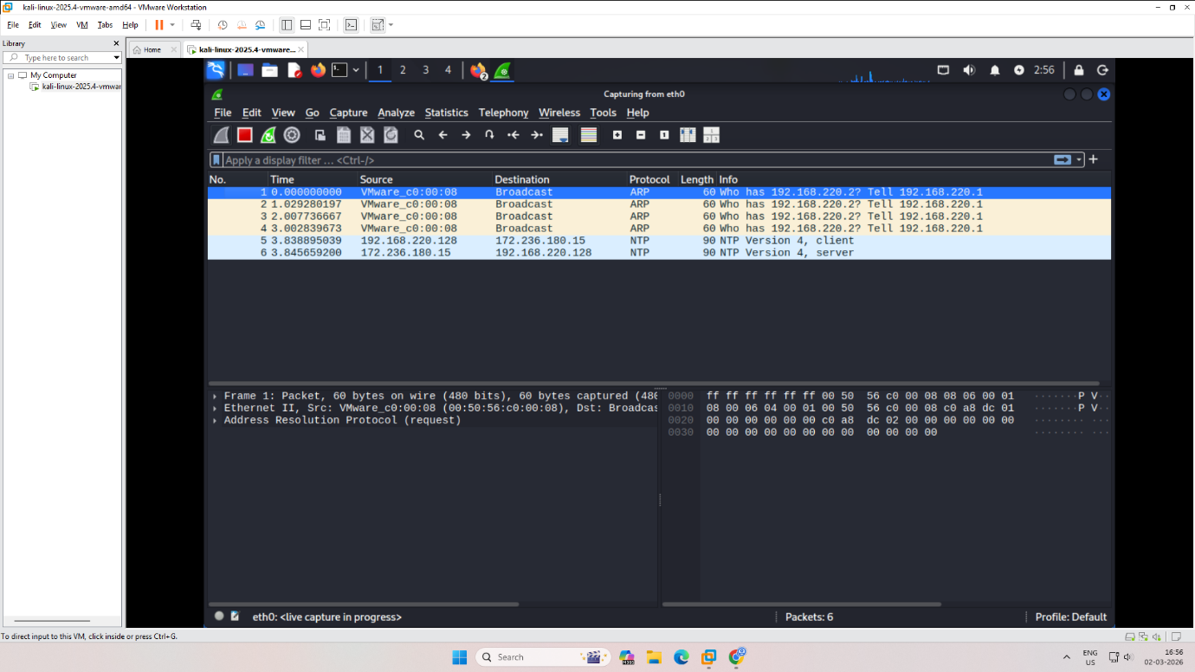
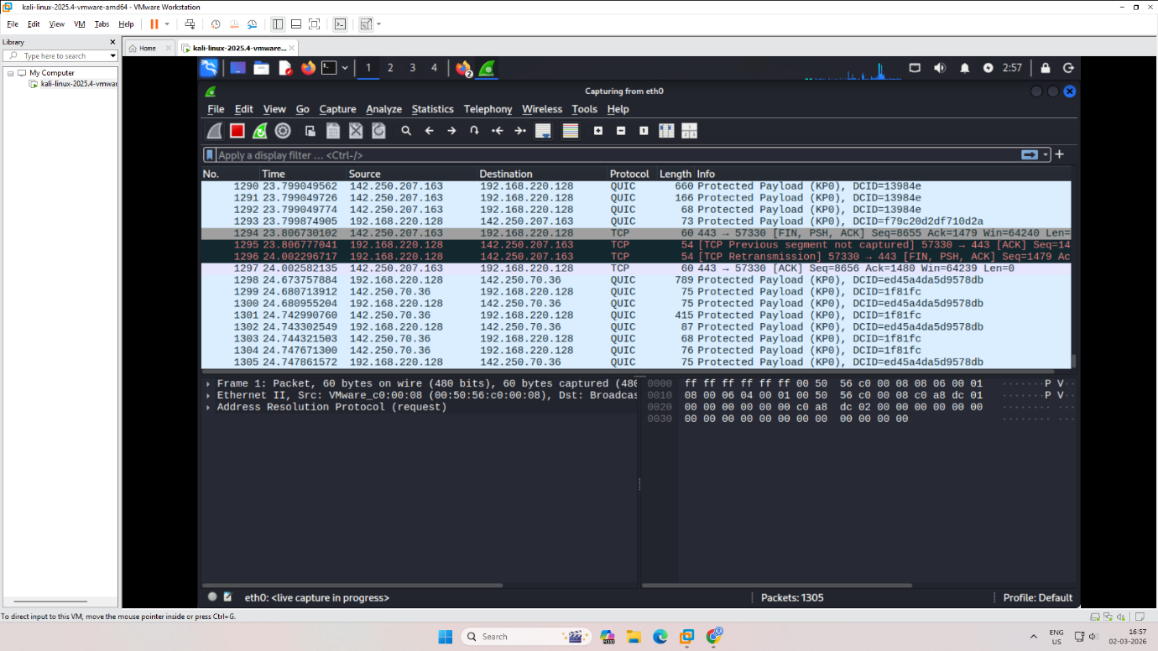

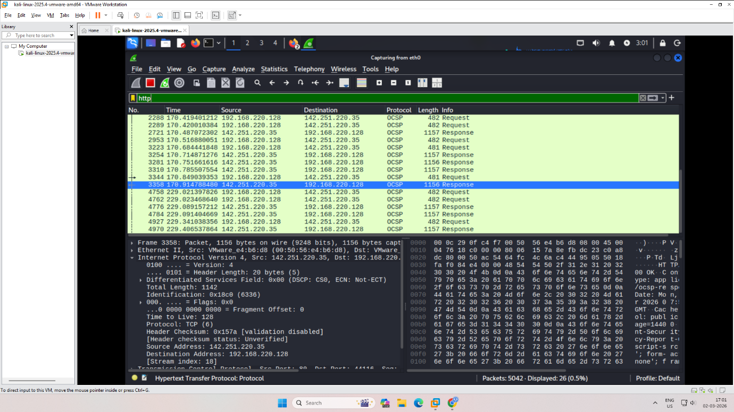
Step 3: DNS Traffic Analysis
DNS packets were filtered using:
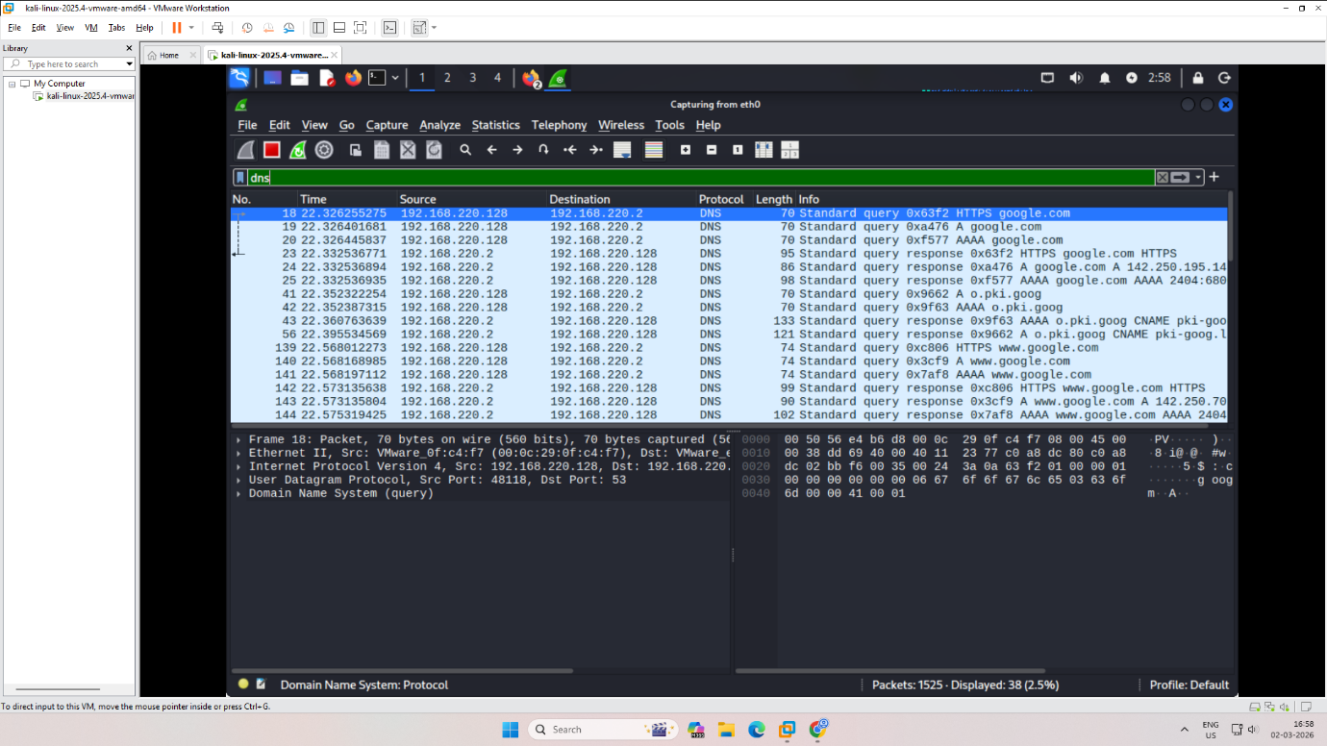

Step 4: HTTP Traffic Analysis
HTTP traffic was filtered using:


5. Observations
- DNS queries were observed for domain resolution.
- HTTP packets contained plaintext requests.
- Port scan generated multiple SYN packets.
- Snort detected unusual traffic patterns.
- 6. Conclusion
- Network traffic analysis helps detect suspicious activities such as port scanning and abnormal packet flows. Tools like Wireshark and Snort are effective for monitoring and intrusion detection.

